
National Textile University
Department of Computer Science
Subject: Mobile and App Development

Submitted to: Rehan Serwer

Submitted by:
Kashmir Jamshaid
Haider Ali

Reg. number:
23-NTU-CS-1167
23-NTU-CS-1164

Project : Gym Fitness Tracker App

Semester:6th

Title of Project:
Gym Fitness Tracker
Description of Project
The Gym Fitness Tracker is a highly interactive, production-ready mobile health and fitness application developed using Flutter (Dart), backed by secure Firebase Authentication/Firestore integration and highly optimized Hive local offline storage. Designed to offer a cohesive, end-to-end fitness lifestyle experience, the application empowers users to seamlessly define their biometric baselines, log real-time active workouts, monitor custom nutritional intakes, and visualize comprehensive analytics—all within an extremely polished, premium design aesthetic.
By employing an offline-first architecture combined with cloud synchronization, user records remain fully operational without internet access while maintaining seamless cross-device authentication state via Firebase. The application enforces clean architectural separation using the Provider state management pattern, ensuring highly responsive tab navigation and real-time state updates across custom workout routines, progress metrics, and live set tracking.
Figma Design Reference
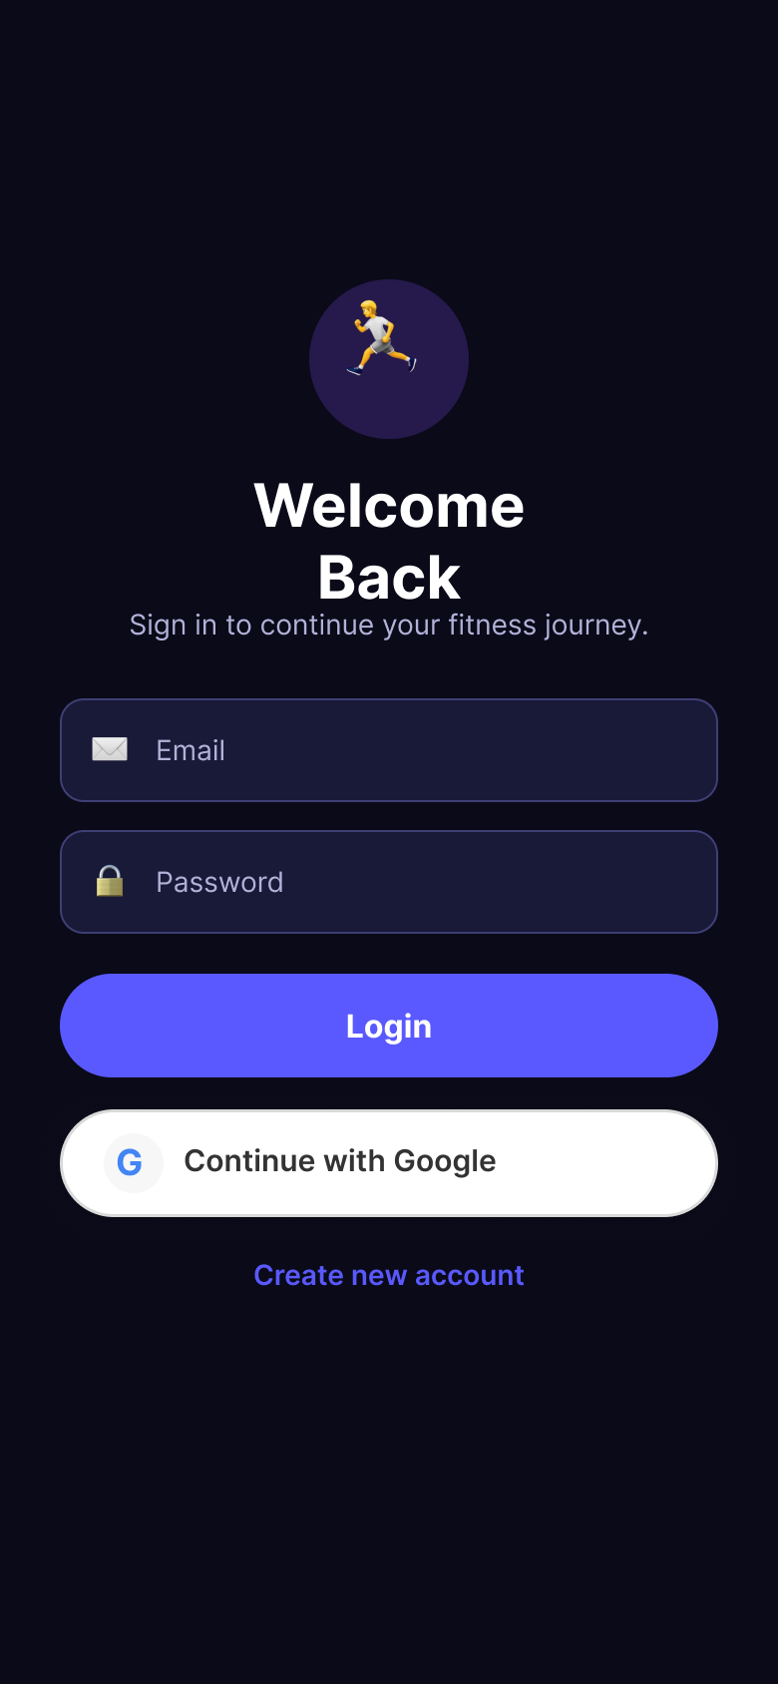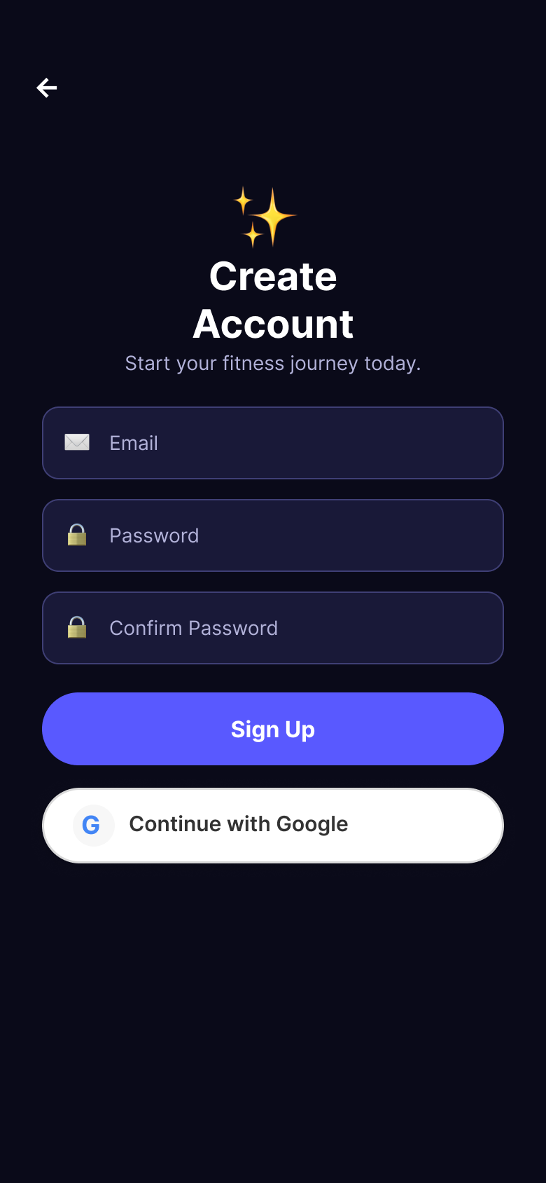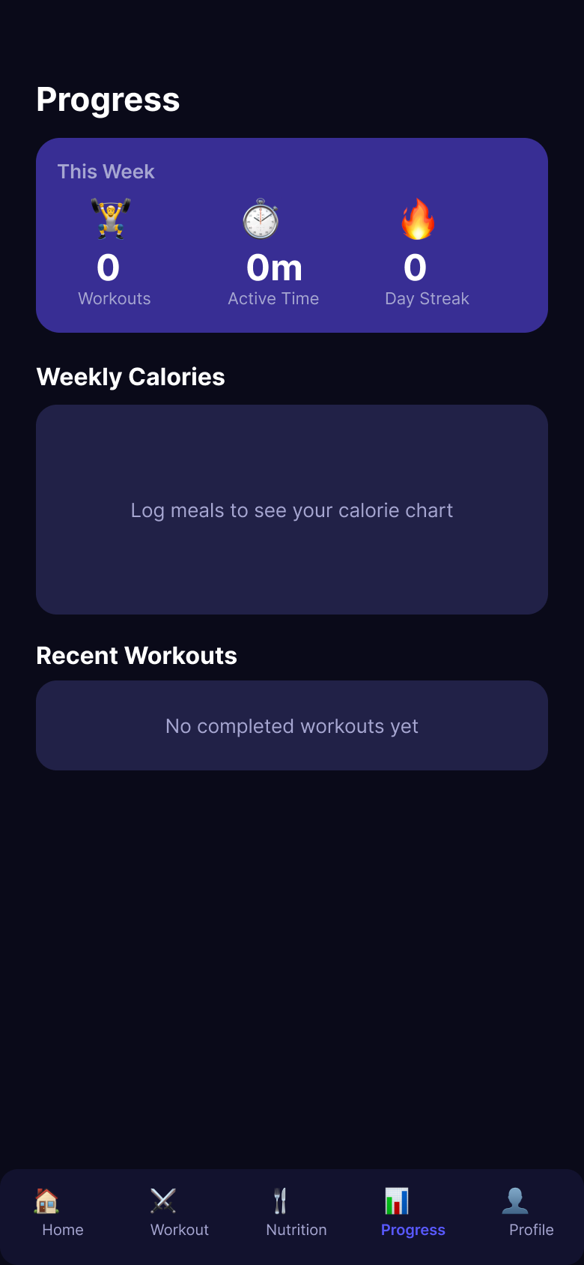
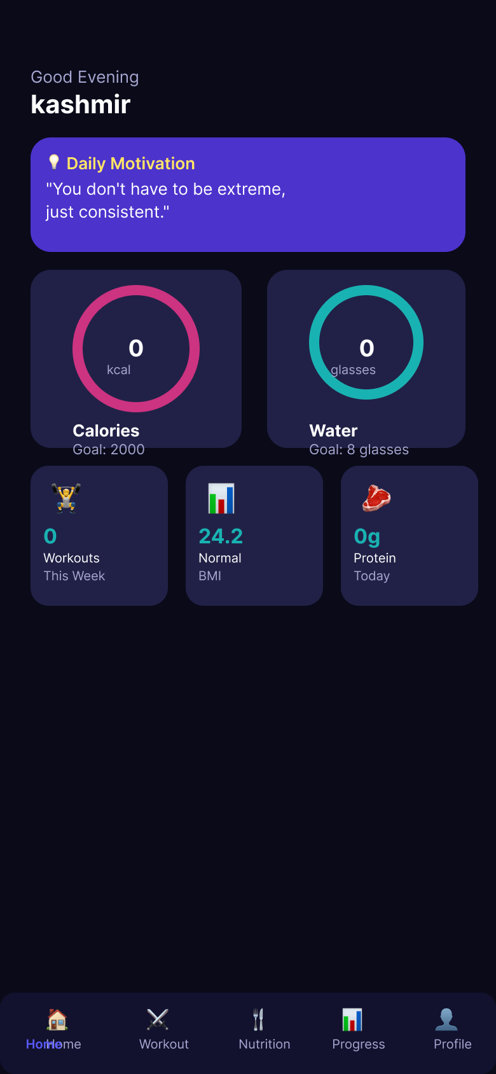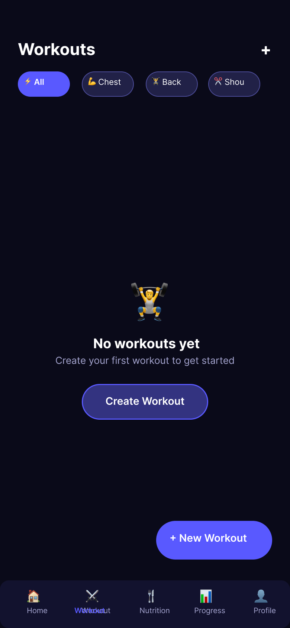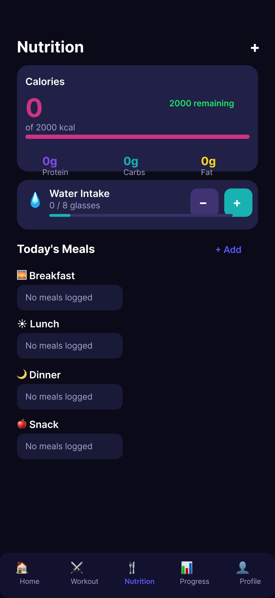
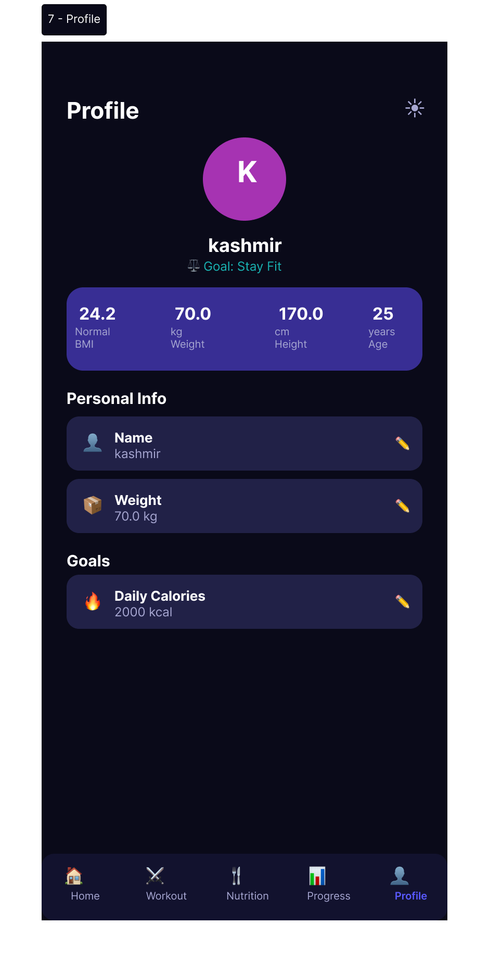
Screen/Pages With Description
1. Splash Screen
Features a centralized premium fitness brand logo over a tailored, rich background gradient. A smooth initialization sequence monitors local storage caching and Firebase session statuses before seamlessly routing the user to the appropriate navigation stream.
2. Login Screen
A streamlined, secure authentication gateway containing intuitive email and password entry fields alongside direct Google Sign-In OAuth integration. Incorporates reactive validation states, automated session recovery via encrypted device storage, and direct navigation routing to the new user registration flow.
3. Signup Screen
A modern registration interface facilitating instant profile creation. Captures basic identification credentials, registers the unique user record within Firebase Authentication, and provisions a synchronized user document inside the Cloud Firestore database for robust cloud presence.
4. Onboarding Screen
An interactive 4-step wizard presented immediately post-registration. Intelligently queries user biometrics including Name, Age, Weight, Height, and individual fitness objectives to automatically formulate baseline metrics such as target Body Mass Index (BMI) and recommended daily hydration volumes.
5. Home / Dashboard Screen
The primary hub displaying a rich daily health snapshot. Prominently highlights consecutive active streak counters, dynamic motivational quotes, visual calorie consumption indicators against daily targets, and an accessible quick-tap water intake tracking component.
6. Workout List Screen
A dedicated catalog indexing the user’s active exercise plans. Categorizes workout routines logically, offering straightforward paths to launch existing regimes, browse pre-configured exercise libraries, or delete stale configurations.
7. Create Workout Screen
An advanced custom workout composer allowing users to assemble personalized routines from an embedded library of over 40 distinct, preloaded exercises mapped by target muscle groups. Supports custom parameter settings for expected set counts, target repetitions, and timed durations.
8. Active Workout Screen
A real-time companion interface deployed during live workout execution. Incorporates individual exercise completion checkboxes paired with an automated rest countdown timer that initiates automatically between consecutive set closures to maintain optimal exercise pacing.
9. Nutrition Screen
A highly structured dietary log enabling granular food tracking split across specific daily windows (Breakfast, Lunch, Dinner, Snacks). Automatically calculates total macronutrient splits (Proteins, Carbs, Fats) alongside a companion interface dedicated to incrementing real-time water consumption.
10. Progress Screen
A visual reporting dashboard leveraging premium fl_chart rendering utilities. Constructs weekly calorie consumption bar charts alongside an interactive, chronological log history tracking previously finished workout sessions for clear developmental visibility.
11. Profile Screen
A comprehensive account settings console presenting recalculated personal statistics. Facilitates seamless metric adjustments, allows immediate toggling between curated Light and Dark modes, and houses complete sign-out controls that successfully invalidate active Firebase and local persistence states.

System Requirements
A. Functional Requirements
- Secure Identity & Session Control: Users must be able to securely sign up, authenticate, and recover sessions utilizing Firebase Email/Password credentials or frictionless Google Sign-In flows.
- Dynamic Biometric Profiling: The application must capture primary health metrics (Age, Weight, Height, Target Goals) during onboarding to calculate real-time targets such as baseline Body Mass Index (BMI) and daily caloric/hydration consumption benchmarks.
- Custom Exercise Execution: Users require complete autonomy to craft personalized workout routines from an embedded 40+ exercise library, configure target repetition parameters, and track active set completions.
- Categorized Food & Water Logging: The architecture must handle split-day dietary inputs (Breakfast, Lunch, Dinner, Snacks), tallying macro-level caloric contributions alongside discrete, one-tap daily hydration volume tracking.
- Historical Analytics: The user must be provided with visual graphic indicators mapping historical weekly nutrition summaries alongside an immutable timeline of past workout sessions.
B. Non-Functional Requirements
- Offline-First Resilience: Operational data tracking (logging meals, tracking workout sets, local progress metrics) must execute instantly through local database caching with zero network dependencies.
- Reactive UI State Management: Application logic must maintain smooth 60fps view transitions, ensuring background synchronization or localized countdown timers do not block UI main thread performance.
- State Persistence & Data Integrity: Local authentication cache states and encrypted user credentials must reliably persist across application restructurings, background state entry, and full runtime closures.

Challenges Faced During Development
1. State Synchronization & Session Desynchronization
- Challenge: Integrating native Google Sign-In SDKs alongside standard Firebase Authentication frequently triggered race conditions. Encrypted local disk caches (SharedPreferences and Hive) occasionally fell out of sync with real-time Firebase Auth user streams, leading to unwanted navigation loops or phantom sessions after explicit user logouts.
2. Post-Logout Auto-Reauthentication
- Challenge: Successful Google Sign-In authorizations established persistent background tokens at the device OS level. Subsequent app logins automatically utilized previously cached credentials without presenting the visual Google Account Selection Picker, preventing users from switching profiles cleanly.
3. Performance Bottlenecks in Live Timer Components
- Challenge: Implementing highly precise, real-time rest interval countdown timers on the Active Workout Screen risked triggering aggressive global widget re-renders, causing noticeable UI frame drops and jittery UI transitions during workout logging.
4. Null-Safety Strictness & Static Analysis Violations
- Challenge: Integrating complex external data models and cloud triggers introduced asynchronous layout constraints. Accessing active widget layouts post-asynchronous invocations triggered strict static warnings (use_build_context_synchronously) and compile-time compilation guard rails.
5. Architectural Separation of Storage Layers
- Challenge: Coordinating disparate database patterns—ensuring rapid operational entries write directly to local offline Hive binary blocks while maintaining an active link to Cloud Firestore for cross-device identity metadata without logical entanglement.

Proposed & Implemented Solutions
1. Synchronized Authentication Validation Streams
- Solution: Designed unified login validation triggers within the AuthProvider class. The logic cross-references reactive Firebase connection states against persistent on-device boolean markers (isLoggedIn) prior to executing final routing switches, eliminating race conditions entirely.
2. Comprehensive Deep-Clean Invalidation Flow
- Solution: Engineered a robust multi-provider logout sequence invoking explicit _googleSignIn.signOut() alongside deep disk clearing (SharedPreferences.clear()). This forces full invalidation of existing API OAuth session states, successfully prompting fresh account selection pickers upon return.
3. Highly Localized Component Reactivity
- Solution: Partitioned root layouts into dedicated modular controllers (UserProvider, WorkoutProvider, NutritionProvider). Applied highly localized Consumer wrappers precisely around active timer countdown widgets to isolate visual re-renders away from the parent layout view tree.
4. Codebase Hardening & Context Caching
- Solution: Enforced defensive programming patterns by caching component statuses prior to starting external API tasks, validating widget execution mounts directly across deep state triggers to maintain absolute compliance with modern Dart analysis rules.
5. Hybrid Data Modeling Architecture
- Solution: Cleanly segregated data handling paths: routing high-frequency read/write metrics (workout histories, custom exercises, active nutritional logs) directly into lightweight local Hive boxes for fast retrieval, while utilizing Cloud Firestore exclusively as a secure key-value user directory.

Tools and Frameworks Summary
- Core Framework: Flutter (Dart)
- Backend Services: Firebase Authentication & Cloud Firestore
- Local Persistence: Hive NoSQL Engine
- State Architecture: Provider Framework
- UI Enhancements: fl_chart, percent_indicator, google_fonts

